Visit Sir John Cass Red Coat School
Sir John Cass Red Coat School
Stepney Way,
London, E1 0RH
www.sjcr.net

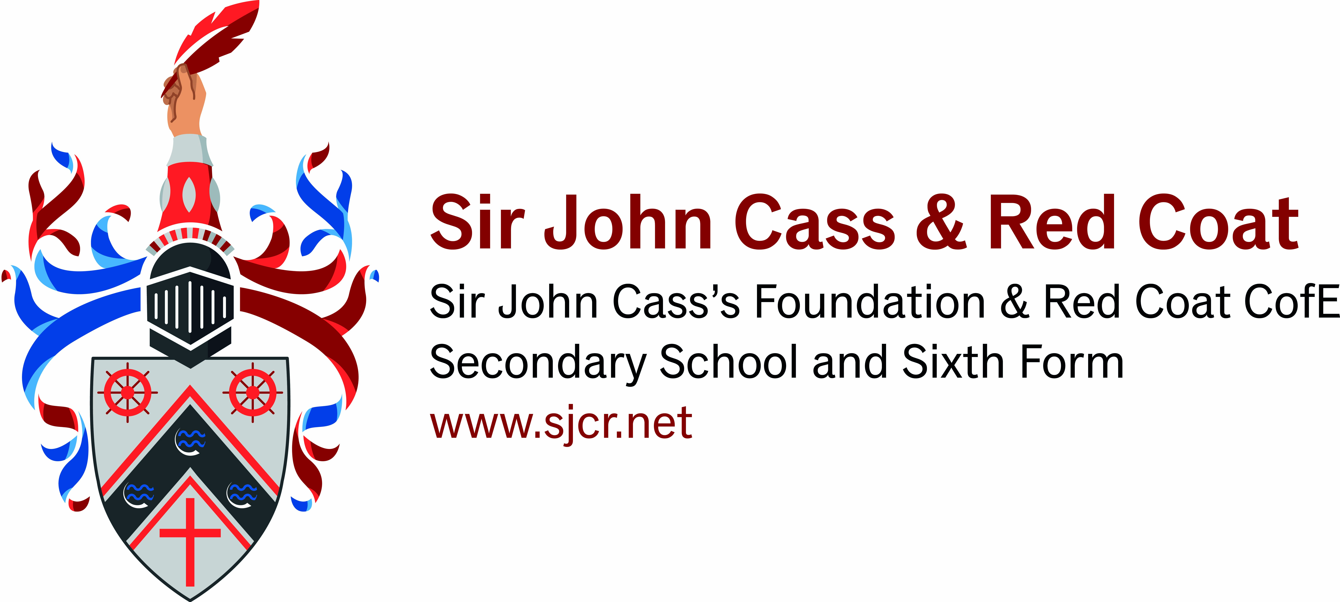


Why should I consider Sir John Cass School?
The Sir John Cass Red Coat is a thriving, successful and innovative voluntary aided school, rich in linguistic and cultural heritage. Ofsted rates our school as OUTSTANDING (Nov 2015) and we were judged to be OUTSTANDING in our SIAMS inspection (May 2018).
Open mornings
Our open mornings provide an excellent opportunity to see our school in action. Book online at www.sjcr.net/visit for your tour of the school. In September and October our open mornings run from 9.30-11.00am.

September  Open morning  Thursday 17th | September  Open morning  Wednesday 23rd | September  Open evening  Monday 28th | October  Open morning  Tuesday 6th
Open evening
In addition to our open mornings we run an open evening on Monday 28th September 2020, 5.00pm - 7.00pm. Book online for a tour of the school to meet staff and students as well as to hear a presentation from our headteacher.

How to get to Sir John Cass’s Foundation & Red Coat School
Details can be found on the Sir John Cass’s Foundation & Red Coat School website www.sjcr.net or you can use the Transport for London website www.tfl.gov.uk to plan your route.


By Bus
- No.15 from Charing Cross.
- No. 309 from Canning Town.
- No. 339 from Bow.
- No. 25 from the City + Ilford
- No. 115 from Aldgate and Poplar
- No. 135 from Liverpool Street, Aldgate

By Tube/DLR
The closest stations to Sir John Cass’s Foundation & Red Coat School are Stepney Green tube (10 minute walk) or Limehouse DLR (5 minute walk).



