June 2020
Dear parents / guardians,

We believe passionately that our uniform gives students a sense of belonging and creates an identity for the school in the community. Full details regarding our uniform can be found as follows:

Authorised Uniform Retailers
The uniform list states which items MUST be purchased from our authorised uniform retailer either in-store or online.
The school’s authorised uniform retailers are;
Khalsa Schoolwear, 388 Bethnal Green Road, London, E2 0AH www.khalsaschoolwear.co.uk
Ocean Design, 10 Watney Market, London E1 2PR
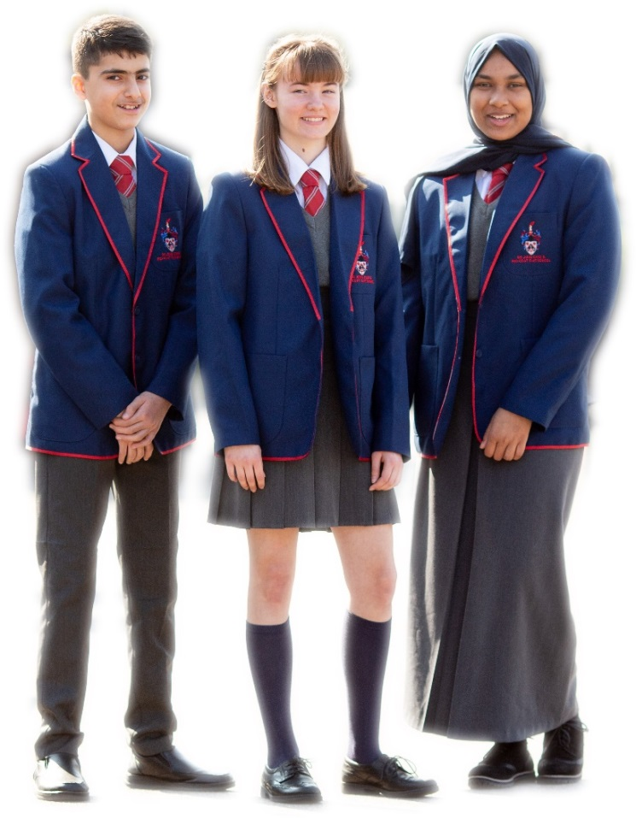
Uniform List
Essential
- White collared shirt/blouse
- Tie (in year colours). Ties should be worn to the correct length, showing at least 7 stripes. Ties will be supplied to all students at the start of year 7. There will be a fee of £5.00 for replacement ties.
- Mid-grey uniform trousers
OR
Mid- grey pleated skirt; of suitable length
OR
Mid- grey full length smart skirt
- School blazer (must be purchased from our authorised retailer)
- Plain black or grey socks (with trousers)
OR
- Knee or ankle length black or grey socks or black coloured seamless tights (with skirt)
- Black low-heeled smart shoes; not trainers or plimsolls
- NO jewellery, other than wrist watches
- Head bands must be black or navy
Optional
- Grey V-neck logo jumper (must be purchased from our authorised retailer)
- Coat - black/navy
- Headscarf (hijab) – navy

PE & Swim Kit
In the interest of health and safety as well as comfort, it is essential that all children change clothes and footwear for Physical Education. Parents are asked to co-operate with the school in providing the essential items of the PE kit. Swimming lessons are compulsory and children should bring with them a towel and appropriate swim kit.

Swim Kit
- Navy blue or black swimming trunks (Lycra/Elastin – NOT baggy surf shorts)
OR
- Navy blue or black 1-piece swimming suit
- Swimming hat
- Goggles
- Towel
- Burkinis, swimming tops and swimming leggings are optional, but must be from a swim brand and worn with swim trunks/suit

PE Kit
- Branded PE T-shirt (must be purchased from our authorised retailer)
- Branded tracksuit top (must be purchased from our authorised retailer)
- Branded tracksuit trousers (must be purchased from our authorised retailer)
OR
- PE shorts (must be purchased from our authorised retailer)
- Red football socks
- Trainers – black
- Shin pads

I would like to reiterate that all students must wear the full and correct uniform for school, school occasions and PE and Drama lessons. Students who come to school dressed incorrectly may, if there is no adequate reason, be sent home to change. In addition, all items of uniform should also be labelled with the student’s name.

Yours sincerely,

Paul Woods
Headteacher

