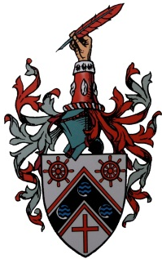
Application form for the Modern Foreign Language Aptitude Test
For September 2018 admission

Test date: 10am Saturday 14th October 2017.
Registering for this test is NOT an application for Sir John Cass Red Coat School.
The Modern Foreign Languages Aptitude Test requires no prior knowledge of any modern foreign language. The aptitude test is designed to indicate a student’s potential to learn a foreign language. The test does not involve any extended writing.

The deadline for applications to take the Modern Foreign Languages Aptitude Test is Friday 6th October. This test is for applications to Year 7 for 2018 entry.

Parents will be notified of the outcome of the aptitude test by Friday 20th October 2017.

To be completed by the child's parent/carer ONLY.
PLEASE INCLUDE ONE PASSPORT SIZED PHOTOGRAPH OF YOUR CHILD WITH THIS APPLICATION

Child’s surname | Child’s forename
Child’s date of birth
Current school | Current school postcode
Home address

Post Code
Email
Daytime telephone number
Mobile number
Does your child suffer from any medical condition? |  | YES | NO
If yes please provide details.

Does your child have a specific learning difficulty which may affect their performance in an aptitude test? Please note that this test will not involve any extended writing. |  | YES | NO
If yes please provide details.

I confirm that I am the parent/carer of the child named above and all the details are true.
Signed (parent/guardian)

Parent/carer’s surname | Parent/carer’s forename
Please return to the admission’s clerk at Sir John Cass Red Coat School, Stepney Way, LONDON, E1 0RH

